4)
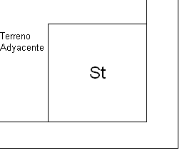
 | Sup. Cubierta | Sup. Semicubierta | Sup. Descubierta
Planta Baja | 1000 | 500 | 1200
Primer Piso | 700 | 30

FOS= 0,8; FOT=1,6

$0,8=\frac{1000{ m}^{2}+0,5∙500 m^{2}}{S_{T}}$ → $S_{T}=1562,5 m^{2}$

$1,6=\frac{1000{ m}^{2}+700 m^{2}+0,5∙(500{ m}^{2}+30 m^{2})}{S_{T}}$ → $S_{T}=1637,5 m^{2}$

Balance de superficies: $S_{T}=1000 m^{2}+500 m^{2}+1200 m^{2}→ S_{T}=2700 m^{2}$

$\frac{L}{A}=1,8$; $L∙A=2700 m^{2}$ $→ 1,8∙A^{2}=2700 m^{2} → A=38,73 m , y L=69,71 m$

$A_{f}=A+3 m=41,73 m$ ; $L_{f}=L+3 m=72,71 m$

$S_{T_{f}}=A_{f}∙L_{f}=3034,19 m^{2}=1,8 ∙A^{2} →A=41,06 m ;L=73,90 m$

